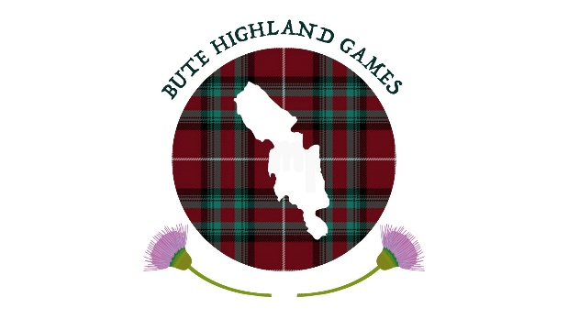
BUTE HIGHLAND GAMES

PRESENTS

(Under Scottish Athletics Laws & Rules)
THE HEAVY EVENTS CHAMPIONSHIPS
----------------------------------
The Duke of Rothesay Trophy
At the Public Stadium, Rothesay on Saturday 12th August 2023

Events Commence 1.00pm Approx.

All athletes must wear kilt & hose

EVENTS
Putting the 16lb Shot
Throwing the 28lb Weight for Distance
Throwing the 16lb Scots Hammer
Throwing the 56lb Weight for Height
Tossing the Caber

MENS EVENT PRIZES
1st £340 2nd £280 3rd £200 4th £150 5th £100 6th £70 7th £60 8th £50

LADIES EVENT PRIZES
1ST £200 2ND £160 3RD £120 4TH £80 5TH £60

ENTRY FEE £5
NO ENTRY ACCEPTED UNLESS ACCOMPANIED BY FEE
-----------------------------------------------------------------------------------------
ENTRIES CLOSE FRIDAY 4th August, 2023 To ALAN PETTIGREW
21 Montfode Drive Ardrossan, AYRSHIRE. KA22 7LS
Telephone 01294 538179 Bute Games
NAME________________________________________________
ADDRESS_____________________________________________
______________________________________________________
CLUB_________________________________________________
DATE OF BIRTH_______________________________________
SAF NO;__________________SGA NO: ___________________

Bute Highland Games will contribute towards travel expenses.
THE COMMITTEE RESERVE THE RIGHT TO WITHHOLD ANY PRIZES IF INSUFFICIENT ENTRIES

